COMPUTER WORKSHOP JOB FILE

Session:2024-2025

UNIVERSITY OF DELHI
FACULTY OF TECHNOLOGY
BACHELORS OF TECHNOLOGY(B.TECH) IN
ELECTRONICS AND COMMUNICATION ENGINEERING

SUBMITTED TO: SUBMITTED BY:
Dr. Sunil Kumar Ashutosh Narayan Srivastava
Assistant professor 1st Year
ECE Department ECE-B
Roll No. - 24294917007

INDEX

S.No. | Topic | Date | Signature
1. | JOB - 1: Assembling, Component Identification and Disassembling of a computer
2. | JOB - 2: Assembling and Disassembling of a Laptop
3. | JOB - 3: Preparation of a network cable
4. | JOB - 4: OS Installation
5. | JOB - 5: PC Maintenance
6. | JOB - 6: Portfolio Website
7. | JOB - 7: To study about AI and ML using teachable website
8. | JOB - 8: Basic Functioning of MS Office
9. | JOB - 9: Tools for online teaching and meeting
10.

JOB – 1
OBJECTIVE: To understand and get familiar with the different components of Computer Hardware required to run a system.

1.1 Steps to Dismantle/ diassemble a Computer System:
1. Make sure to turn off your system.
2. Unplug or remove all connected cables to the system unit.
3. Remove screws of side covers of system case.
4. Disconnect and remove all the cables connected inside the system unit.
5. Remove the ODD or CD ROM.
6. Remove the HDD (untighten the screws mounted to case and then carefully remove HDD) and PSU.
7. Remove the motherboard untighten the screws mounted on case.
8. Now, unmount and unplug all the parts along the motherboard including CPU CPU’s Heat Sink Fan, RAM, Video Card.

HARDWARE:
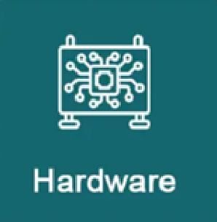
Figure 1.

- Computer hardware includes the physical parts of a computer, such as the central processing unit (CPU), random access memory (RAM), motherboard, computer data storage, graphics card, sound card, and computer case. It includes external devices such as a monitor, mouse, keyboard, and speakers.
- Hardware is typically directed by the software to execute any command or instruction.
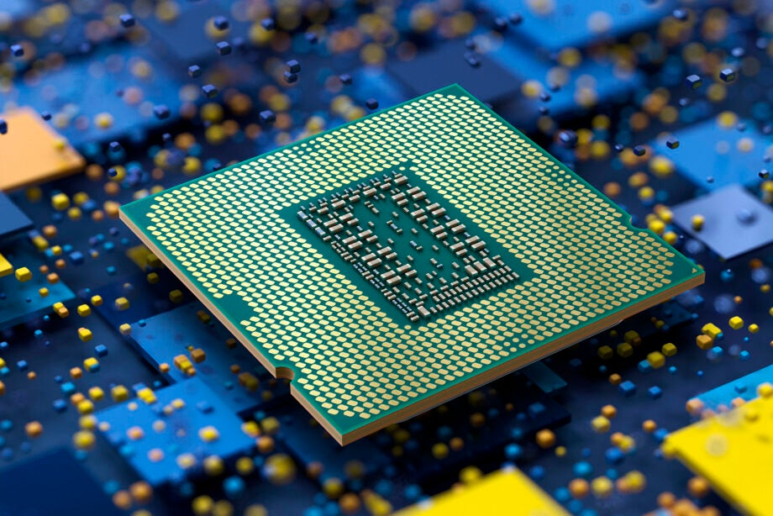
Figure 2. Processor
- CPU:

Principal components of a CPU include:

- The arithmetic–logic unit (ALU) :that performs arithmetic and logic operations. It is a combinational digital circuit that performs arithmetic and bitwise operations on integer binary numbers. It is a fundamental building block of many types of computer circuits.

- Control Unit that regulates the fetching (from memory), decoding and execution (of instructions) by directing the coordinated operations of the ALU.

- Small Scale Integration (SSI):
The first integrated circuits contained only a few transistors. Early digital circuits containing tens of transistors provided a few logic gates, and early linear ICs.

- Medium Scale Integration (MSI):
It contained hundreds of transistors on each chip. MOSFET scaling technology made it possible to build high-density chips.

- Large scale Integration (LSI):
It consisted of tens of thousands of transistors per chip. True LSI circuits, approaching 10,000 transistors, began to be produced around 1974, for computer main memories and second-generation microprocessors.

- Very-Large-Scale Integration (VLSI):
Very-large-scale integration" (VLSI) is a development started with hundreds of thousands of transistors in the early 1980s, and, as of 2023, transistor counts continue to grow beyond 5.3 trillion transistors per chip.

- Generations of Computer:

- The technology behind the first-generation computers was a fragile glass device, which was called a vacuum tube. These computers were very heavy and really large. They are not reliable, programming on them was a tedious task as they used low-level programming language and used no Operating System. First-generation computers were used for calculation, storage, and control purposes.
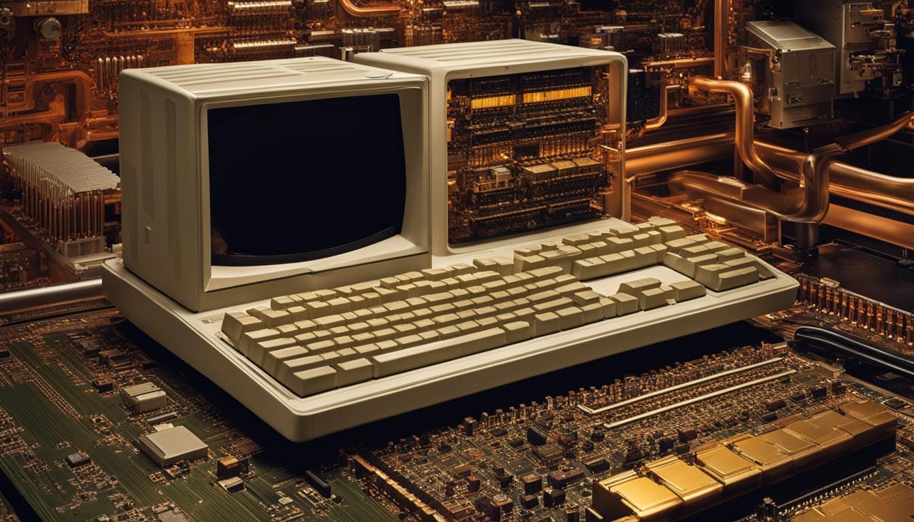
Figure 3. 1st Gen vacuum tube computers
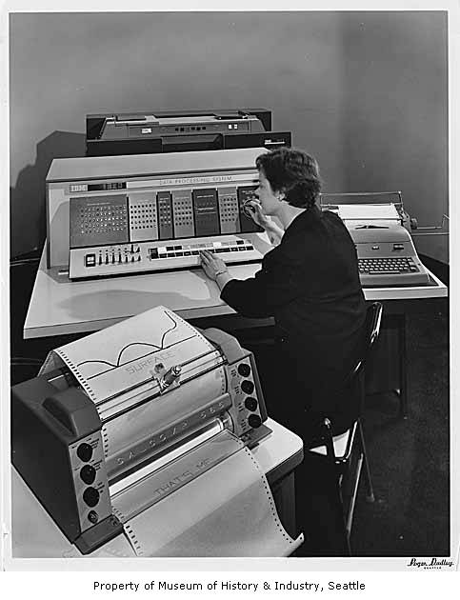
Figure 4. 2nd Gen Transistor Computers
- The second-generation computers were used during 1957-1963. They are also known as transistor computers. The second generation of computers consists of two types of devices, transistors, and magnetic core. The transistors helped to develop a better computer than the first-generation computers consisting of vacuum tubes.

- The third-generation computer was started in 1965 and ended around 1971. Third generation computers start using integrated circuits instead of transistors. The integrated circuit (IC) is a semiconductor material, that contains thousands of transistors miniaturized in it. With the help of IC, the computer becomes more reliable, fast, required less maintenance, small in size, generates less heat, and is less expensive.
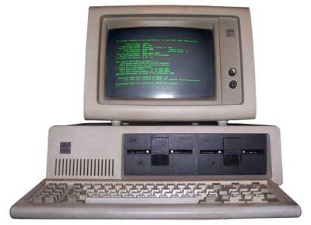
Figure 5. 3rd Gen IC computers

- Fourth-generation computers were released in 1972. VLSI technology, or Very Large Scale Integrated (VLSI) circuits, was employed in these computers. As a result, they were dubbed microprocessors. VLSI circuits contained about 5000 transistors on a very compact chip and could conduct a wide range of high-level activities and computations.
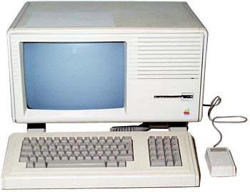
Figure 6. 4th Gen VLSI computer

- Fifth-generation computers, also known as modern computers, are still in the development stage and are based on artificial intelligence. Computers of this generation are based on microelectronic technology with high computing power and parallel processing.
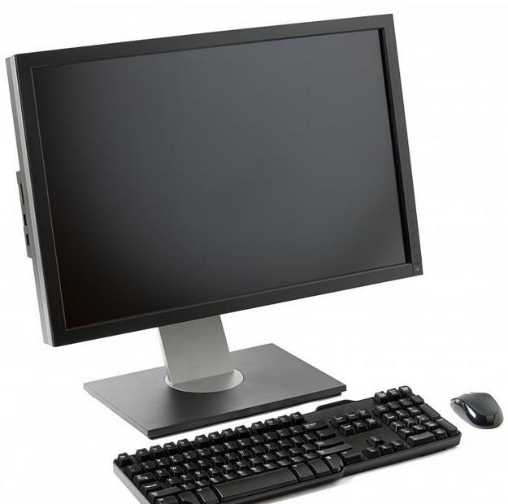
Figure 7. Modern Computer

- MEMORY:

- RAM:
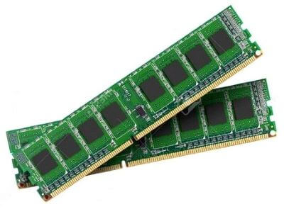
Random Access Memory, is the temporary
storage in a computer that allows applications
to store and access data on a short-term basis.
It is the main memory in a computer and is
much faster to read from and write to than
Figure 8. RAM
other types of storage, such as a hard disk drive,
solid-state drive, or optical drive.

- Types of RAMS:
- Error correction code memory (ECC memory) is a type of computer data storage that uses an error correction code (ECC) to detect and correct n-bit data corruption which occurs in memory.
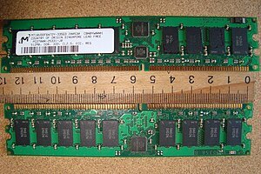
Figure 9. ECC Memory

- Static random-access memory (static RAM or SRAM) is a type of random-access memory (RAM) that uses latching circuitry (flip-flop) to store each bit. SRAM is volatile memory; data is lost when power is removed.
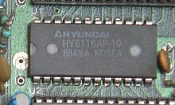
Figure 10. SRAM chip
- Dynamic random-access memory (dynamic RAM or DRAM) is a type of random-access semiconductor memory that stores each bit of data in a memory cell, usually consisting of a tiny capacitor and a transistor, both typically based on metal–oxide–semiconductor (MOS) technology.
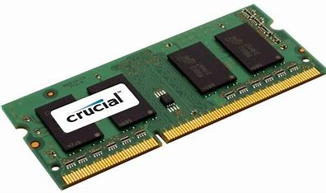
Figure 12. DDR2

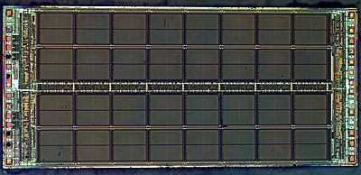
Figure 11. DRAM

- Double Data Rate 2 (DDR2 SDRAM) is a double data rate (DDR) synchronous dynamic random-access memory (SDRAM) interface.

- Double Data Rate 4 Synchronous Dynamic Random-Access Memory (DDR4 SDRAM) is a type of synchronous dynamic random-access memory with a high bandwidth ("double data rate") interface.
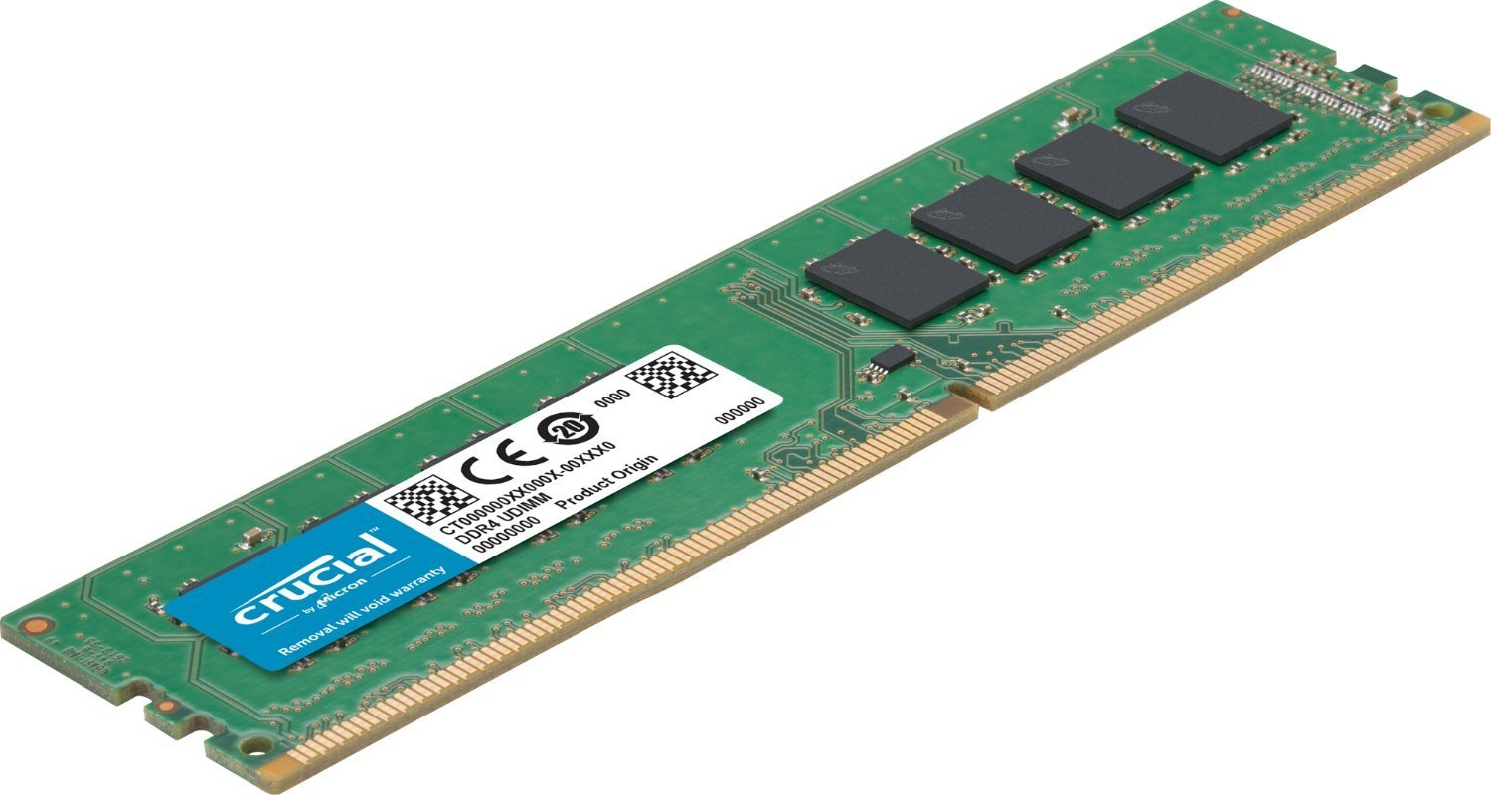
Figure 13. DDR4

- ROM:
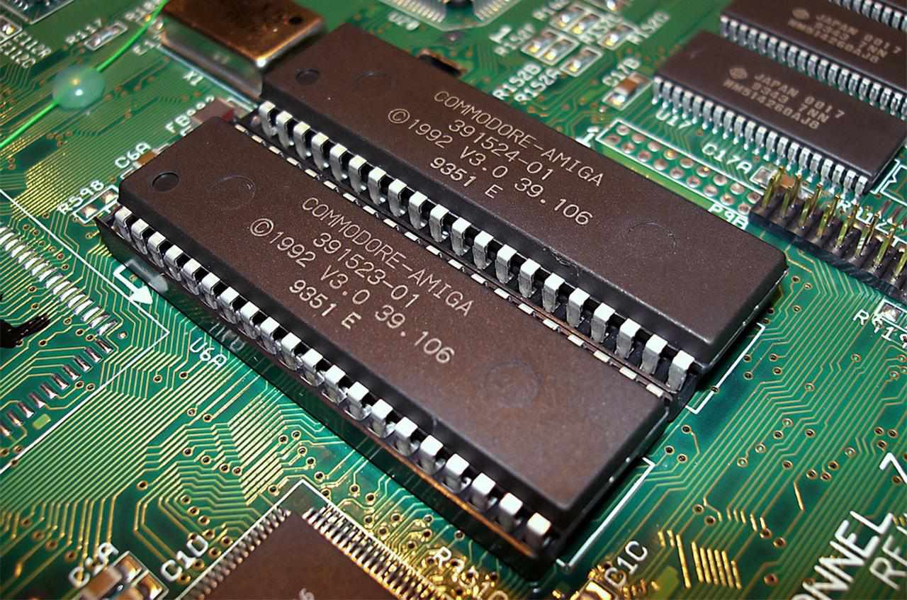
Figure 14. ROM
Read-only memory is a type of non-volatile memory used in computers and other electronic devices. Data stored in ROM cannot be electronically modified after the manufacture of the memory device. Read-only memory is useful for storing software that is rarely changed during the life of the system.
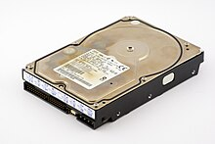
Figure 15. Hard drive

- HDD:
A hard disk drive (HDD) is a non-volatile data storage device that is usually installed internally in a computer, attached to the computer's motherboard. HDDs are non-volatile, meaning they retain stored data even when power isn't being supplied.
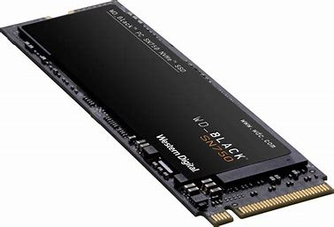
Figure 16. NVME
- NVME SSD:
NVM Express (NVME) or Non-Volatile Memory Host Controller Interface Specification (NVMHCIS) is an open, logical-device interface specification for accessing a computer's non-volatile storage media usually attached via the PCI Express bus.

- MOTHERBOARD:

A motherboard also called a mainboard is the main printed circuit board (PCB) in general-purpose computers and other expandable systems. It holds and allows communication between many of the crucial electronic components of a system, such as the (CPU) and memory, and provides connectors for other peripherals.
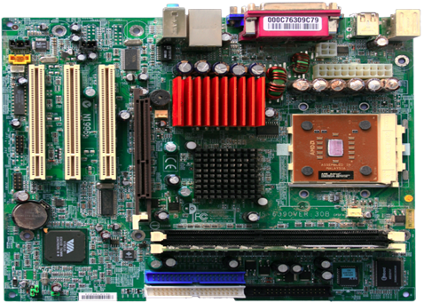
Figure 17. Motherboard

A motherboard usually contains significant sub-systems, such as the central processor, the chipset’s input/output and memory controllers, interface connectors, and other components.

Components of a motherboard:
- Mouse and keyboard connectors: CPU sockets (or CPU slots) in which one or more microprocessors may be installed.
- Memory slots into which the system's main memory is to be installed.
- The chipset which forms an interface between the CPU, main memory, and peripherals.
- Non-volatile memory chips (usually flash memory in modern motherboards) containing the system's firmware or BIOS.
- Universal serial Bus (USB): These ports connect a wide range peripheral devices directly to the motherboard.
- Basic input/output system (BIOS): The BIOS is a firmware that initializes hardware components during startup.
- CMOS Battery: This is a small battery that keeps some necessary settings safe, even when the computer is off.
Functions of the motherboard:
- Central Hub: The motherboard acts as a central hub, which converts various hardware components and enables them to work together. It is a communication channel between CPU, memory and storage devices.
- Data transfer: The motherboard facilitates data transfer between components through data buses, ensuring efficient communication.
- Memory Management: Memory slots on the motherboard hold RAM modules. RAM is essential for temporary data, storage.
- Expansion Slots: Expansion slots on the motherboard allow for the installation of expansion cards, like graphics cards and network adapters.
- CPU Connection: The motherboard provides a socket where the CPU is inserted. This socket enables the CPU to interface with other components, execute instructions, and process data.
- BIOS/UEFI Management: This firm firmware initializes hardware during startup, manages system settings and facilitates the boot process.
- Power: The motherboard distributes power from the power supply unit (PSU) to different components through power connection.

- INPUT DEVICES: A piece of equipment used to provide data and control signals to an information processing system.
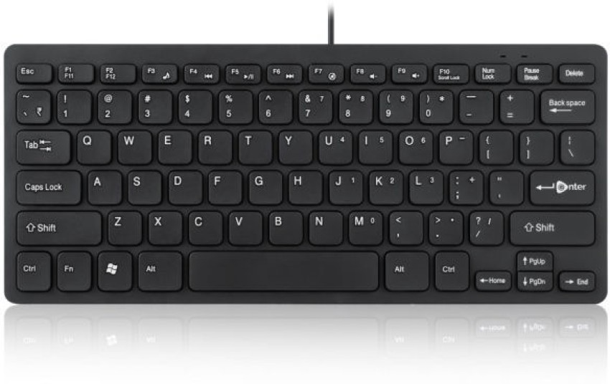
Figure 18. Keyboard
- Keyboard:
It is a human interface device which
is represented as a matrix of buttons.
Each button, or key, can be used to
either input an alphanumeric character
to a computer, or to call upon a particular function of the computer.
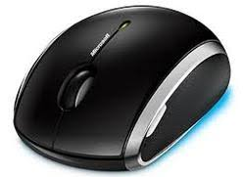
Figure 19. Mouse
- Pointing device:
It is commonly used as a simple and intuitive way to select items on a computer screen on graphical user interface (GUI), either by moving a mouse
Pointer, or by a touch screen.
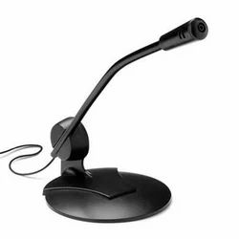
Figure 20. Microphone

- Microphone:
A microphone is a transducer that
converts sound into an electrical signal.

- Scanner:
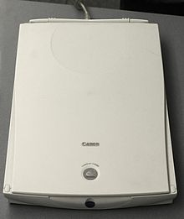
Figure 21. Scanner
A device that optically scans images,
printed text, handwriting or an
object and converts it to a digital image.

- Joystick:
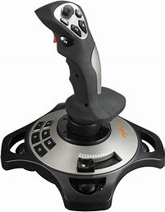
Figure 22. Joystick
A joystick, sometimes called a flight stick, is an input device consisting of a stick that pivots on a base and reports its angle or direction to the device it is controlling.

- OUTPUT DEVICES: Any piece of computer hardware that converts information or data into a human-perceptible form.

- Monitor:
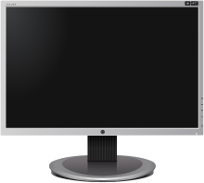
Figure 23. Monitor
A computer monitor is an output
device that displays information in
pictorial or textual form.

- SCREENS AND ITS TYPES:

- A thin-film-transistor liquid-crystal display (TFT LCD) is a type of liquid-crystal display that uses thin-film-transistor technology to improve image qualities such as addressability and contrast.

- A LED display is a flat panel display that uses an array of light-emitting diodes (LEDs) as pixels for a video display. LED displays are capable of providing general illumination in addition to visual display.

- A liquid-crystal display (LCD) is a flat-panel display or other electronically modulated optical device that uses the light-modulating properties of liquid crystals combined with polarizers.

- An organic light-emitting diode (OLED), also known as organic electroluminescent (organic EL) diode, is a type of light-emitting diode (LED) in which the emissive electroluminescent layer is an organic compound film that emits light in response to an electric current.

- Speakers:
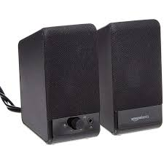
Figure 24. Speakers
A speaker is an output device that
produces sound through a transducer
called a driver. The equivalent
input device is a microphone.

- Projector:
A projector or image projector is
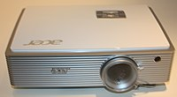
Figure 25. Projector
an optical device that projects an
image (or moving images) onto a
surface, commonly a projection screen.

- Printers:

A printer is a peripheral machine which makes a durable representation of graphics or text, usually on paper. While most output is human-readable, bar code printers are an example of an expanded use for printers.

- Types of Printers:
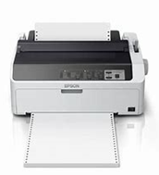
Figure 26. Impact Printer
- Dot matrix printing, sometimes called impact matrix printing, is a computer printing process in which ink is applied to a surface using a relatively low-resolution dot matrix for layout.
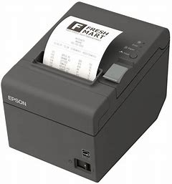
Figure 27. Thermal Printer
- Thermal printing (or direct thermal printing) is a digital printing process which produces a printed image by passing paper with a thermochromic coating, over a print head consisting of tiny electrically heated elements.
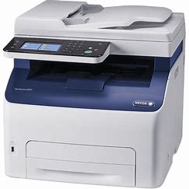
Figure 28. LED Printer
- An LED printer is a type of computer printer similar to a laser printer. Such a printer uses a light-emitting diode (LED) array as a light source in the printhead instead of the laser used in laser printers and, more generally, in the xerography process.
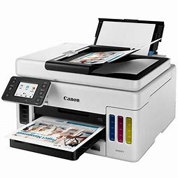
Figure 29. Inkjet Printer
- Inkjet printing is a type of computer printing that recreates a digital image by propelling droplets of ink onto paper and plastic substrates. Inkjet printers were the most commonly used type of printer in 2008.

- Computer’s cooling system:

- Heat Sink: A heat sink is a passive cooling device that absorbs and dissipates heat from the CPU. It is made of metal (Aluminium or Copper) with fans or other structures that increase the surface area for better heat dissipation.
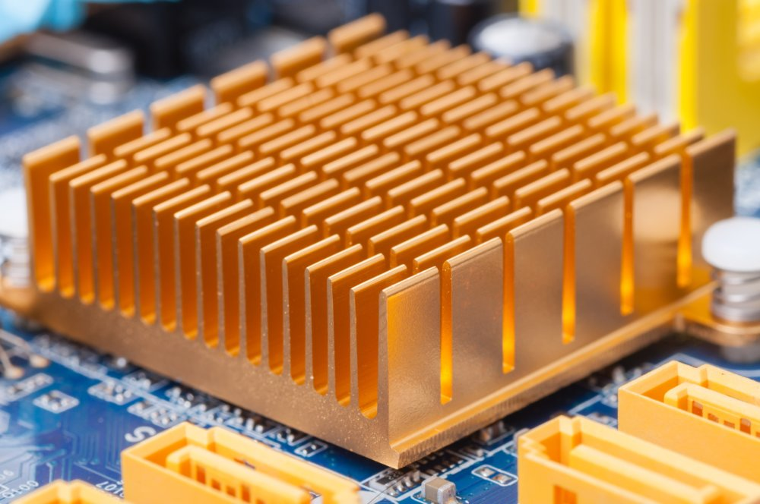
Figure 30. Heat Sink
It is mounted directly on the CPU or thermal interface material which enhances the thermal conductivity. The primary function is to transfer heat away from the CPU.
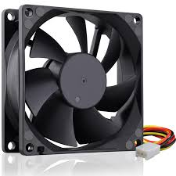
Figure 31. Cooling Fan
- CPU Fan: It is an active cooling device that blows air over the heat sink to accelerate the heat dissipation process. It is typically mounted on top of the heat sink. The fan helps to maintain a lower temperature preventing the CPU from overheating.

- Power Supply Unit (PSU):

A power supply unit (PSU) is a hardware component of a computer that converts alternating high voltage current (AC) into a steady low-voltage DC (direct current) usable by the computer.

It regulates the DC output voltage to the fine tolerances required for modern computing components. The PSU is where the power cord plugs into and usually has an I/O power switch on it. It is connected to the rest of the computer by various power cables that supply the motherboard, hard drives, and case electronics with the electricity they need to function.
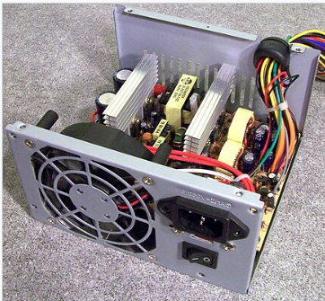
Figure 33. SMPS
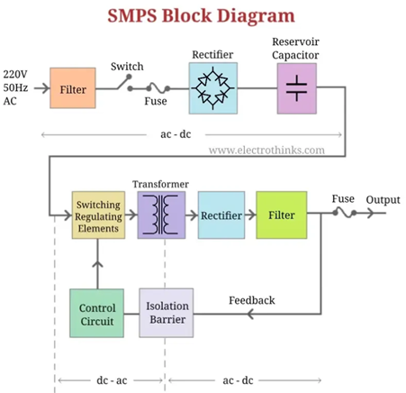
Figure 32. SMPS Block Diagram

Power conversion: The primary function of a PSU is to convert alternating current (AC) into direct current (DC) suitable for computer’s internal components.

Voltage Regulation: It ensures that the computer receives a stable and consistent power supply.

Power connectors: The PSU provides various power connectors to supply electricity to different components inside the CPU.

- CABLES:
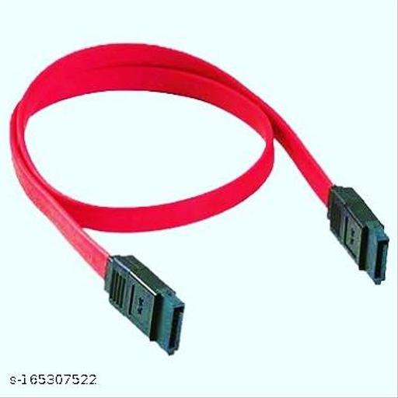
Figure 34. Sata Cable
- Sata:

The Sata Cable (Serial advanced technology attachment) is mainly used to connect the internal hard drive to the computer motherboard. It connects hard drives i.e. solid state disks (SSD).

- Pata:

Parallel ATA (PATA), originally AT Attachment, also known as Integrated Drive Electronics (IDE), is a standard interface designed for IBM PC-compatible computers. It was first developed by Western Digital and Compaq in 1986 for compatible hard drives and CD or DVD drives.
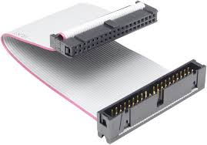
Figure 35. PATA Cable

- Category 5 cable (Cat 5):
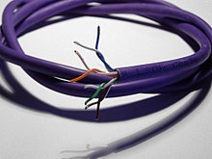
Figure 36. CAT5 Cable

It is a twisted pair cable for computer networks. Since 2001, the variant commonly in use is the Category 5e specification (Cat 5e). Cat 5 is also used to carry other signals such as telephone and video.

- Category 6 cable (Cat 6):
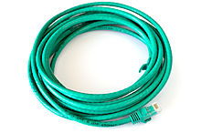
Figure 37. CAT6 Cable

It is a standardized twisted pair cable for Ethernet and other network physical layers that is backward compatible with the Category 5/5e and Category 3 cable standards. Cat 6 must meet more stringent specifications for crosstalk and system noise.

- RJ-45:

A Registered Jack (RJ-45) is a standardized telecommunication network interface for connecting voice and data equipment to a computer service provided by a local exchange carrier or long-distance carrier. It is basically used for Ethernet networks.
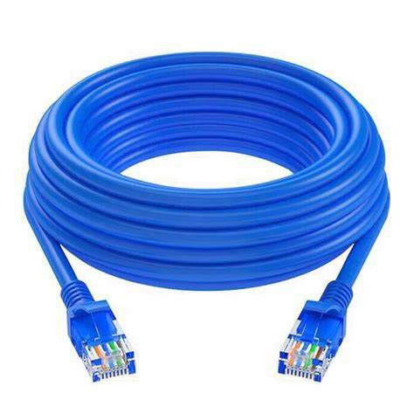
Figure 38. RJ-45 Cable

- CD-ROM:
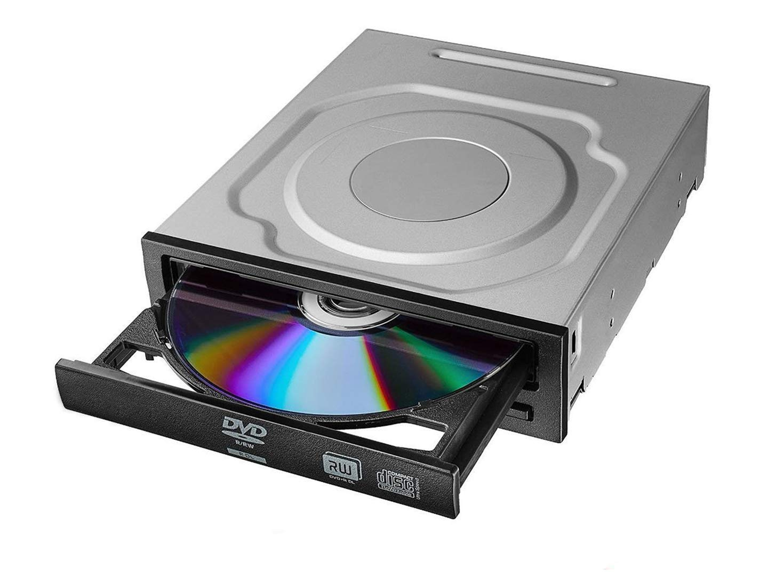
Figure 39. CD-ROM
CD-ROM (Compact Disc Read only Memory) is a read only optical media format that uses CDs to store data. A single disc can store upto 700 MB of data. A computer with an optical drive can read, but not write, data on a CD-ROM.
The digital data is encoded and stored as a series of pits on a flat reflective layer on the bottom of the disc.

- Video Card:

Video card or graphic card is a computer extension card that generates a feed of graphics output to a display
device such as a monitor. It contains a graphic processing unit (GPU), a digital- to-analog converter and memory chips that store display data. The card is usually located on the computer’s motherboard or in a separate circuit board but is sometimes built into the computer’s display unit. It processes data in the form of pixels, making it possible to stream videos, play games in high resolution and create intricate animations.
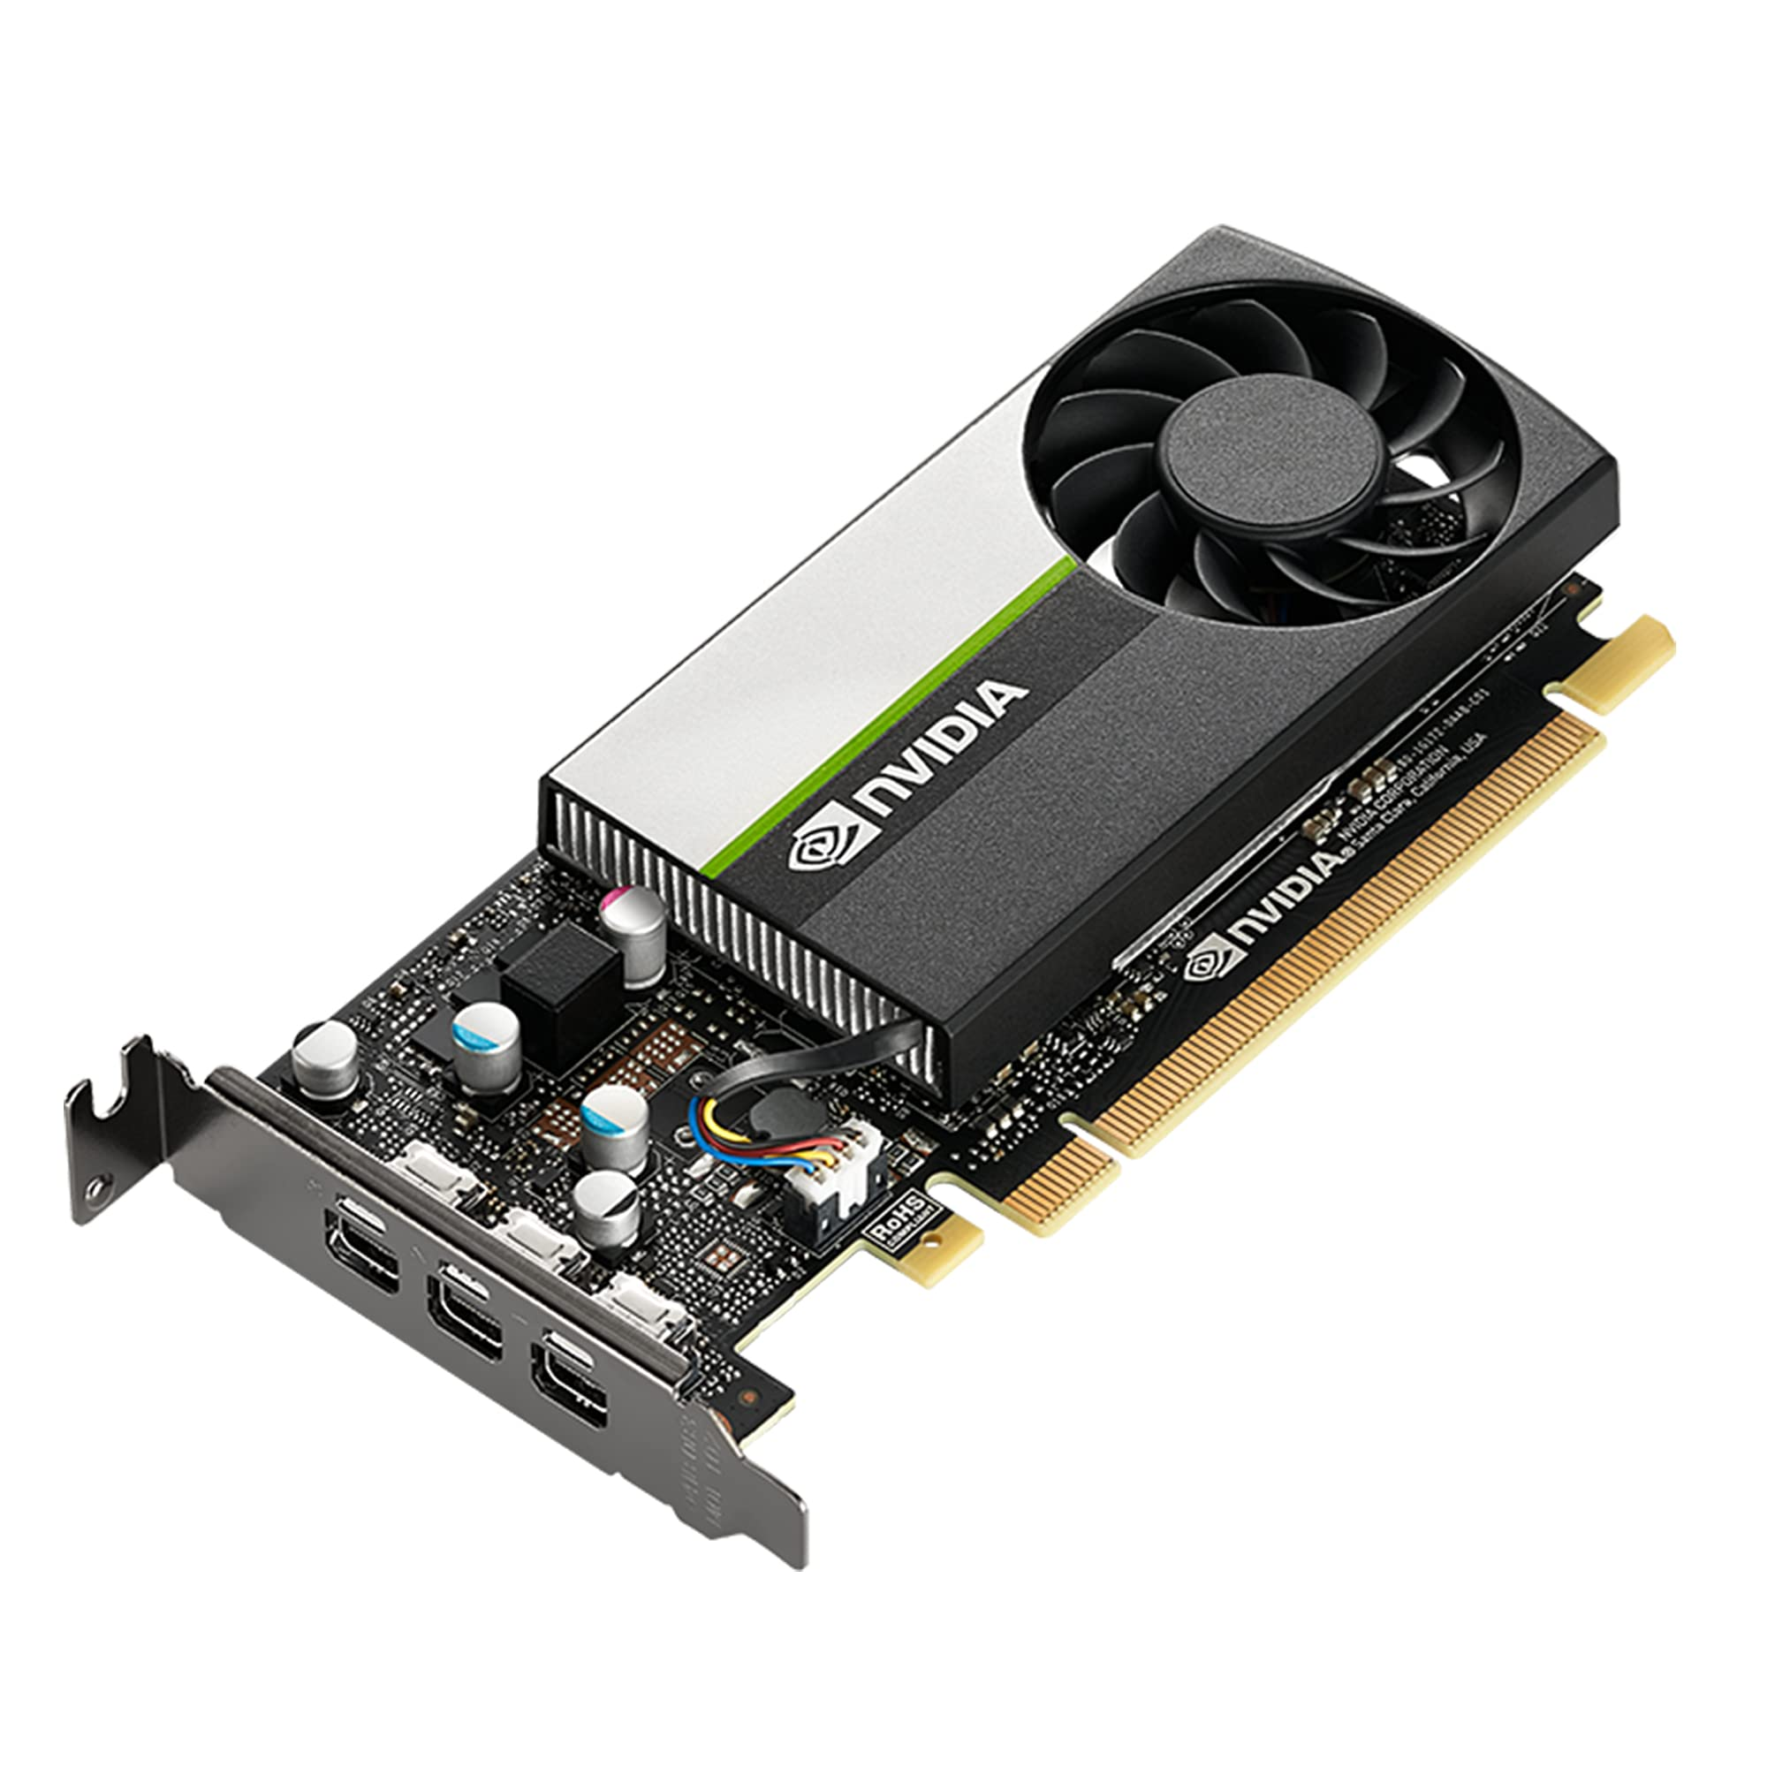
Figure 40. Video Card

- MAC Address:
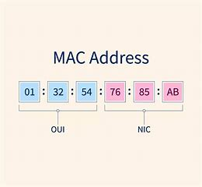
Figure 41. MAC Address
A MAC address (Medium access control address) is a unique identifier assigned to a network interface controller (NIC) for use as a network address in communications within a network segment. This 48-bit address space contains potentially 2⁴⁸ (over 281 trillion) possible MAC addresses.

- IP Address:

An Internet Protocol address (IP address) is a numerical label such as 192.0.2.1 that is assigned to a device connected to a computer network that uses the Internet Protocol for communication. IP addresses serve two main functions: network interface identification, and location addressing.
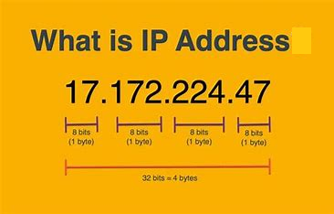
Figure 42. IP Address

- Internet Protocol version 4 (IPv4) is the first version of the Internet Protocol (IP) as a standalone specification. It is one of the core protocols of standards-based internetworking methods in the Internet and other packet-switched networks. IPv4 uses a 32-bit address space.

- Internet Protocol version 6 (IPv6) is the most recent version of the Internet Protocol (IP), the communications protocol that provides an identification and location system for computers on networks and routes traffic across the Internet. IPv6 uses 128-bit addresses.

- CHASSIS (System Unit Case):

The chassis is the housing that helps protect and organize all the components that make up a desktop computer.
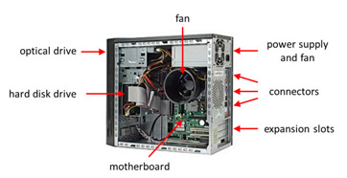
Figure 43. System Unit Case

- Steps for Assembly of the computer System:

1. Mount all the parts along the motherboard.
2. Install the motherboard tighten the screws mounted to case.
3. Install the PSU.
4. Install ODD/ CD ROM.
5. Carefully install the HDD tighten the screws mounted to case.
6. Connect all the cables to all components inside the system unit.
7. Put side cover back and tighten the screws.
8. Connect all the cables to system unit.
9. Test the system unit if it is working well.

- Raspberry Pi:
- Raspberry Pi is the name of a series of single board computers made by the Raspberry Pi foundation, a UK
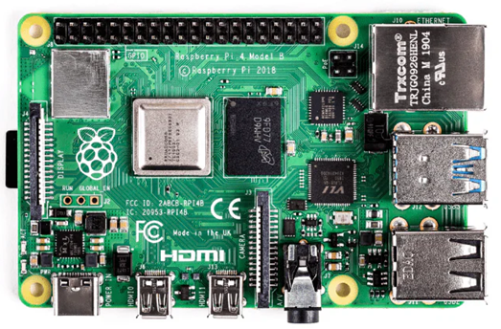
Figure 44. Raspberry Pi

- charity that aims to educate people in computing and create easier access to computing education.
- The Raspberry Pi launched in 2012, and there have been several iterations and variations released since then.

- It is a very cheap computer that runs Linux, but it also provides a set of GPIO (General Purpose input/output) pins allowing you to control electronic components for physical computing and explore the Internet of Things (IOT).

CONCLUSION:

We have successfully performed and understood the disassembly, component identification and reassembly of a computer. And also it
Enhances both technical knowledge and practical skills.It fosters a deeper appreciation for technology and empowers user to make informed decision regarding their computer systems.

